Topic: TryHackMe: Introductory Networking
Lab Overview
Platform: TryHackMe
Room:Introductory Networking
Status: Completed

1. Introduction
In this section, I learned that the purpose of this room is to give a beginner-level introduction to networking and build a basic foundation before moving into more advanced networking concepts.
The room focuses on four main areas:
- OSI Model
- TCP/IP Model
- How these models work in practice
- Basic networking tools
This section helped me understand what topics I would be learning throughout the room and gave me an overview of the practical side of networking.

2. The OSI Model
In this section, I learned about the OSI (Open Systems Interconnection) Model and how it is used to understand how communication happens over a network.
The OSI model has 7 layers, and each layer has a different responsibility. I learned what each layer does, from the Application layer (Layer 7) down to the Physical layer (Layer 1).
I also learned about TCP and UDP at the Transport layer, IP addresses at the Network layer, and MAC addresses at the Data Link layer. This helped me understand how data moves through different stages during network communication.

Questions and Answers
Question:
“Which layer would choose to send data over TCP or UDP?”
My answer: 4
Why:
I answered 4 because the Transport layer is Layer 4, and this layer chooses between TCP and UDP.

Question:
“Which layer checks received information to make sure that it hasn't been corrupted?”
My answer: 2
Why:
I answered 2 because the Data Link layer checks received information to make sure it has not been corrupted during transmission.

Question:
“In which layer would data be formatted in preparation for transmission?”
My answer: 2
Why:
I answered 2 because the Data Link layer prepares the data in a format suitable for transmission.

Question:
“Which layer transmits and receives data?”
My answer: 1
Why:
I answered 1 because the Physical layer handles the transmission and receiving of data as signals through the network hardware.

Question:
“Which layer encrypts, compresses, or otherwise transforms the initial data to give it a standardised format?”
My answer: 6
Why:
I answered 6 because the Presentation layer handles data formatting, encryption, compression, and other transformations.

Question:
“Which layer tracks communications between the host and receiving computers?”
My answer: 5
Why:
I answered 5 because the Session layer establishes and maintains communication sessions between computers.

Question:
“Which layer accepts communication requests from applications?”
My answer: 7
Why:
I answered 7 because the Application layer provides networking options and interfaces for applications to communicate.

Question:
“Which layer handles logical addressing?”
My answer: 3
Why:
I answered 3 because the Network layer handles logical addressing using IP addresses and determines the route for data.

Question:
“When sending data over TCP, what would you call the ‘bite-sized’ pieces of data?”
My answer: Segments
Why:
I answered segments because the room explains that when TCP is used, the transmission is divided into smaller pieces called segments.

Question:
“Which layer would the FTP protocol communicate with?”
My answer: 7
Why:
I answered 7 because FTP is an application-level protocol, so it communicates with the Application layer.

Question:
“Which transport layer protocol would be best suited to transmit a live video?”
My answer: UDP
Why:
I answered UDP because live video generally needs speed more than perfect accuracy. UDP does not wait for lost packets to be retransmitted, making it more suitable for real-time communication.
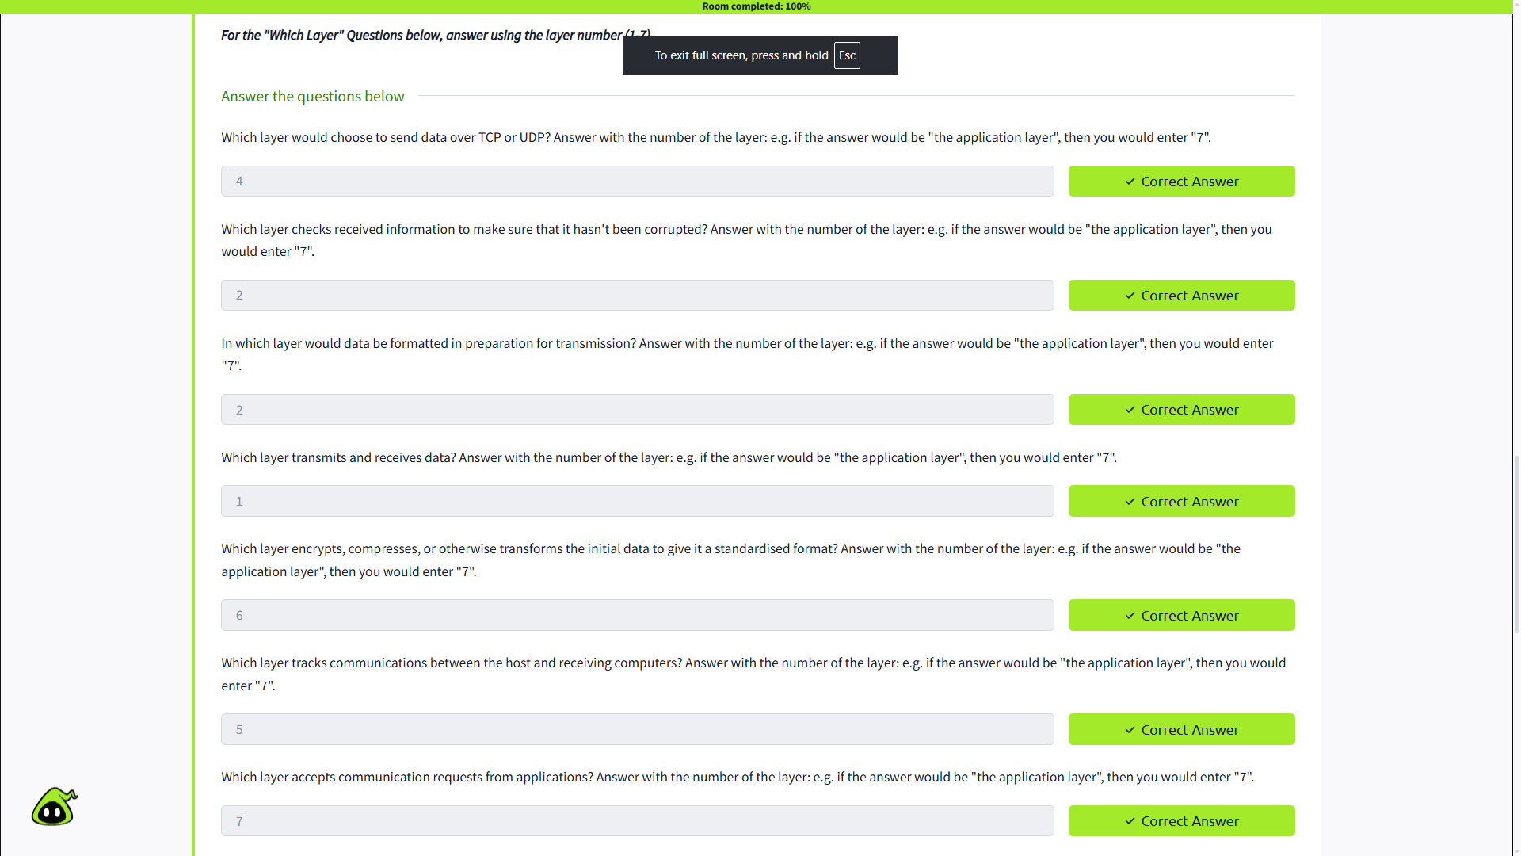

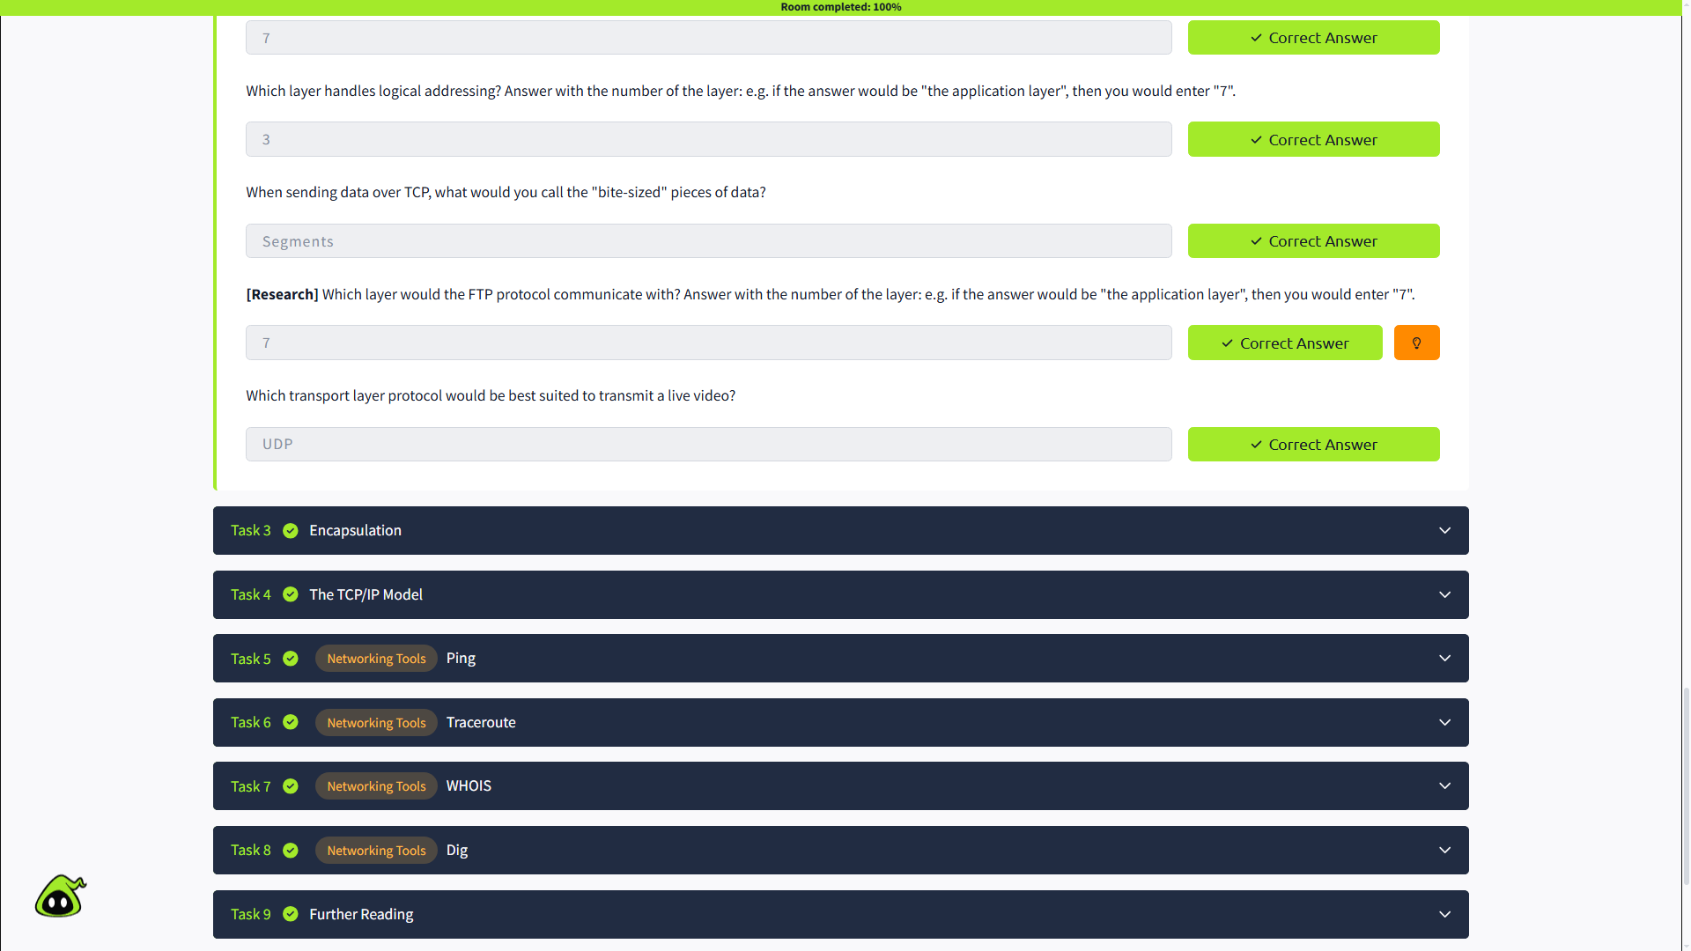

4. The TCP/IP Model

4.1 Introduction

The TCP/IP model is a four-layer networking model that serves as the basis for real-world networking. It is similar to the OSI model, but it combines some of the OSI layers into fewer layers.

The four layers are:

Application

Transport

Internet

Network Interface

The TCP/IP model covers similar networking functions as the seven-layer OSI model.

4.2 TCP/IP and OSI Model Mapping

The TCP/IP layers correspond to the OSI model as follows:

Application Layer → Session, Presentation and Application

Transport Layer → Transport

Internet Layer → Network

Network Interface Layer → Data Link and Physical

The TCP/IP model also uses encapsulation and de-encapsulation. Headers are added as data moves through the layers during transmission and removed when the data is received.

4.3 TCP/IP Protocol Suite

TCP/IP is not only a model; it also represents a suite of protocols used for network communication.

Two important protocols are:

TCP — Transmission Control Protocol: Controls the flow of data between two endpoints.

IP — Internet Protocol: Handles how packets are addressed and sent.

4.4 TCP Three-Way Handshake

TCP is a connection-based protocol, meaning a connection must be established before data can be transmitted.

The connection is established using a three-way handshake:

Step 1 — SYN
The client sends a SYN request to start a connection.

Step 2 — SYN + ACK
The server responds with SYN and ACK, acknowledging the request.

Step 3 — ACK
The client sends an ACK to confirm that the connection has been established.

SYN = Synchronise
ACK = Acknowledgement

After the handshake is completed, data can be reliably transmitted between the two endpoints.

4.5 History

The TCP/IP model was introduced first to provide standardisation for networking. Different manufacturers previously followed different networking methods, which caused compatibility problems.

The OSI model was introduced later and is commonly used as a more detailed framework for learning networking concepts.

4.6 Task Questions & Answers

Q1. Which model was introduced first, OSI or TCP/IP?
Answer: TCP/IP
Why: The TCP/IP model was introduced in 1982, while the OSI model was introduced later. TCP/IP was developed to provide standardisation for networking.

Q2. Which layer of the TCP/IP model covers the functionality of the OSI Transport layer?
Answer: Transport
Why: The TCP/IP Transport layer performs the same core transport functions as the OSI Transport layer, including communication between endpoints.

Q3. Which layer of the TCP/IP model covers the functionality of the OSI Session layer?
Answer: Application
Why: The TCP/IP model is more condensed than the OSI model. Its Application layer combines the functionality of the OSI Session, Presentation, and Application layers.

Q4. The Network Interface layer covers Data Link and which OSI layer?
Answer: Physical
Why: The TCP/IP Network Interface layer combines the functions of the OSI Data Link and Physical layers.

Q5. Which TCP/IP layer handles the functionality of the OSI Network layer?
Answer: Internet
Why: The TCP/IP Internet layer handles packet addressing and routing, which corresponds to the main functionality of the OSI Network layer.

Q6. What kind of protocol is TCP?
Answer: Connection-based
Why: TCP is connection-based because a connection must first be established between two endpoints before data can be transmitted reliably.

Q7. What is SYN short for?
Answer: Synchronise
Why: SYN is short for Synchronise and is used in the first step of the TCP three-way handshake to begin establishing a connection.

Q8. What is the second step of the three-way handshake?
Answer: SYN + ACK
Why: After receiving the client's SYN, the server responds with SYN + ACK, showing that it received the request and is acknowledging it while also synchronising its side of the connection.

Q9. What is the short name for the "Acknowledgement" segment in the three-way handshake?
Answer: ACK
Why: ACK is the standard short form of Acknowledgement. In the final step of the handshake, the client sends an ACK to confirm the connection.

Key Takeaway

The questions helped me understand how the TCP/IP model maps to the OSI model and how TCP establishes a connection using the SYN → SYN/ACK → ACK process. 🔎
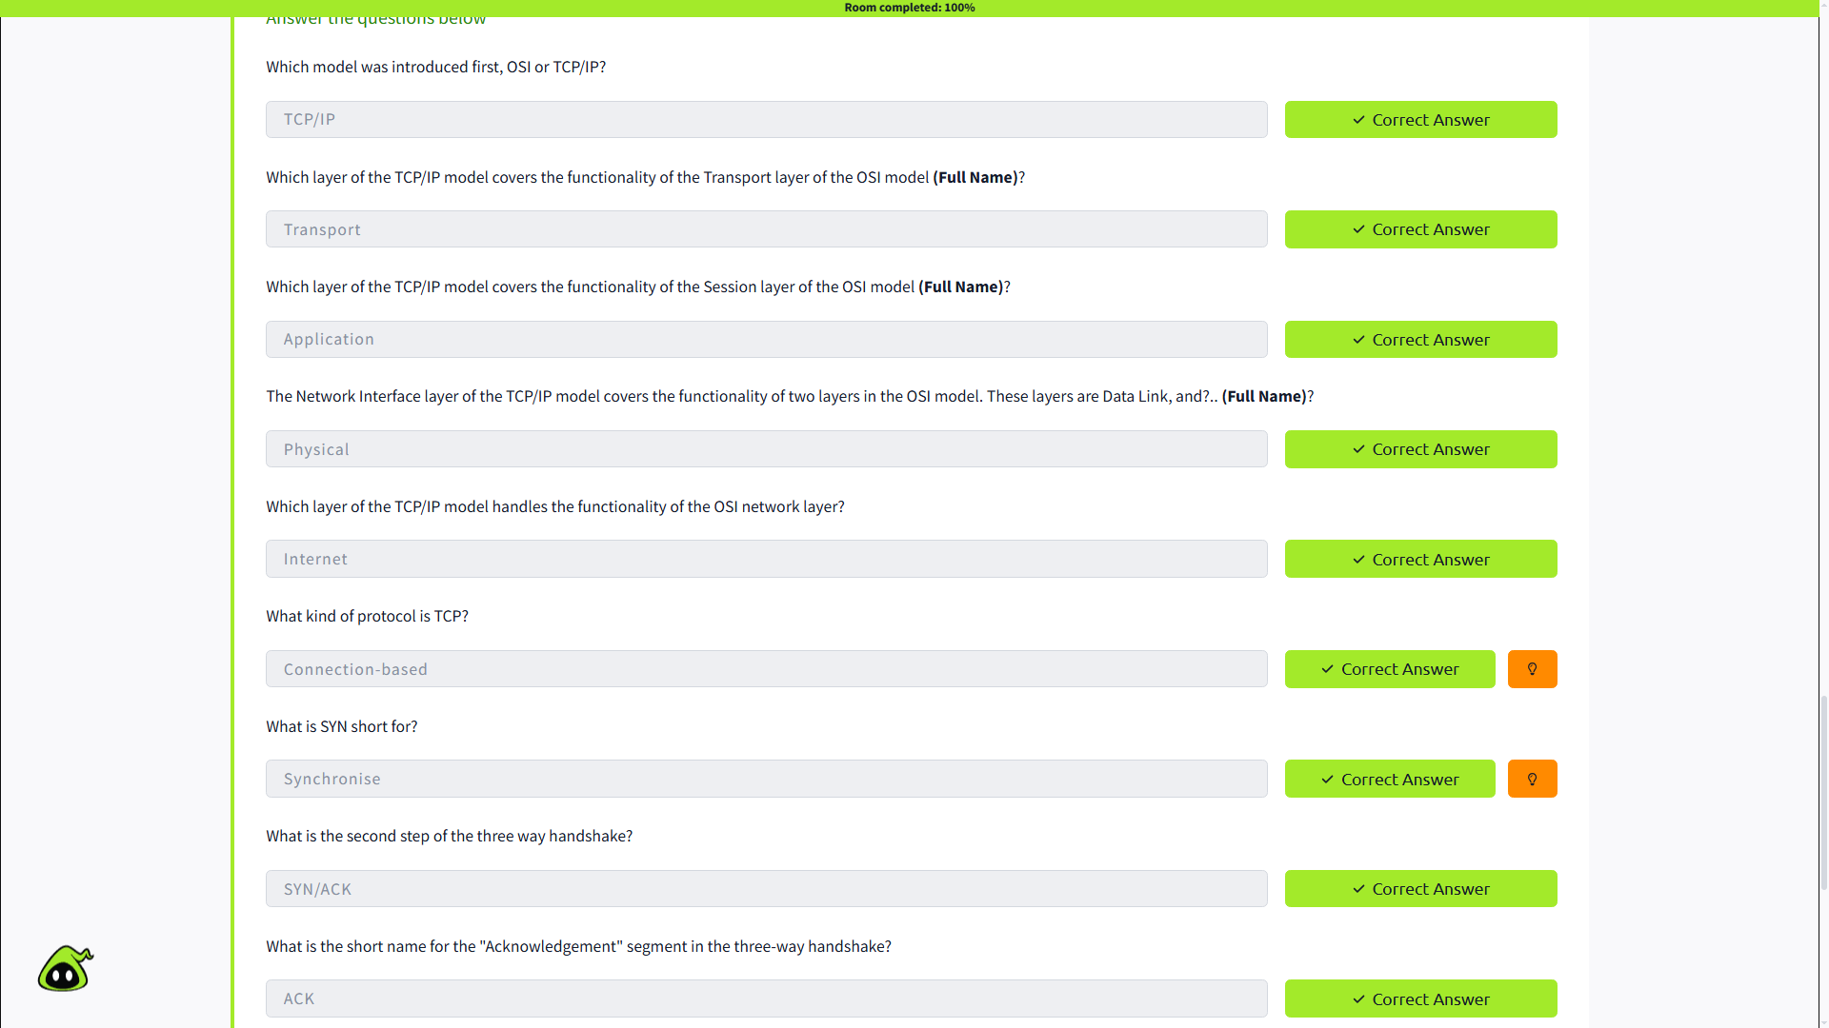

3. Encapsulation
In this section, I learned how data is prepared as it moves through the different layers of the OSI model.
As data moves down the layers, each layer adds its own information to the transmission. This process is called encapsulation. When the data reaches the other computer, the process happens in reverse, and this is called de-encapsulation.
I also learned that the data gets different names at different layers:
- Layers 7, 6, 5 → Data
- Layer 4 → Segment (TCP) or Datagram (UDP)
- Layer 3 → Packet
- Layer 2 → Frame
- Layer 1 → Bits

Questions and Answers
Question:
“How would you refer to data at layer 2 of the encapsulation process (with the OSI model)?”
My answer: Frame
Why:
I answered Frame because when data reaches Layer 2, the Data Link layer, it is referred to as a frame.

Question:
“How would you refer to data at layer 4 of the encapsulation process, if the UDP protocol has been selected?”
My answer: Datagram
Why:
I answered Datagram because UDP data at the Transport layer is called a datagram. TCP data at the same layer would be called a segment.

Question:
“What process would a computer perform on a received message?”
My answer: De-encapsulation
Why:
I answered De-encapsulation because the receiving computer removes the information added during encapsulation as the data moves back up through the OSI layers.

Question:
“Which is the only layer of the OSI model to add a trailer during encapsulation?”
My answer: Layer 2 — Data Link
Why:
I answered Layer 2 because the Data Link layer adds a trailer at the end of the transmission. It is used to help verify that the data has not been corrupted during transmission.

Question:
“Does encapsulation provide an extra layer of security (Aye/Nay)?”
My answer: Aye
Why:
I answered Aye because the room explains that the trailer added during encapsulation can provide an additional security benefit by making unauthorized modification easier to detect.
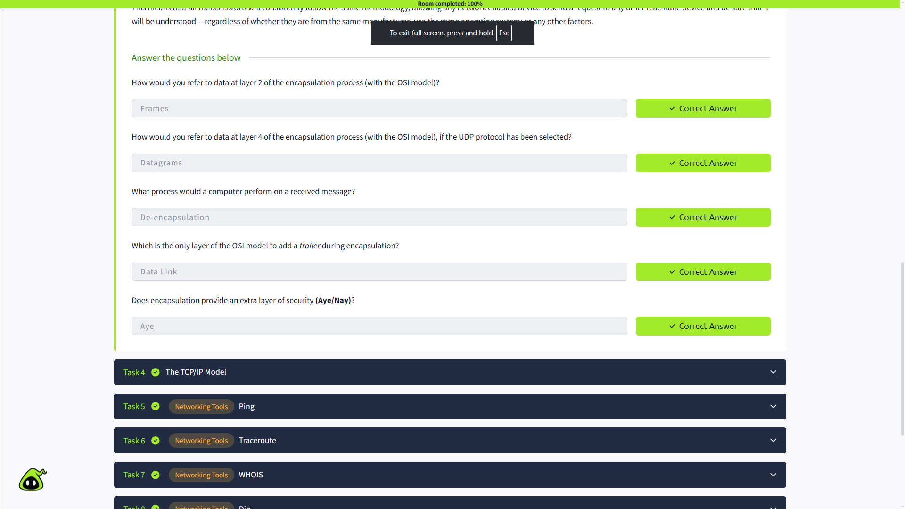

4. Networking Tools — Ping
In this section, I learned how to use the ping command as a basic networking tool. Ping is used to check whether a connection to another device or website is possible.
I learned that Ping uses the ICMP protocol, which works at the Network layer of the OSI model. I also learned that Ping can show the IP address of a website when we use its domain name.
The basic syntax is:
ping <target>
This section helped me understand how a simple command-line tool can be used to test connectivity and get basic information about a remote host.

Questions and Answers
Question:
“What command would you use to ping the bbc.co.uk website?”
My answer: ping bbc.co.uk
Why:
I used the ping command followed by the website domain because this is the basic syntax for testing connectivity to a target.

Question:
“Ping muirlandoracle.co.uk — What is the IPv4 address?”
My answer: [Enter the IPv4 address you got from the lab]
Why:
When a domain is pinged, the command can show the IP address of the server associated with that domain. I used the result shown by the TryHackMe lab.

Question:
“What switch lets you change the interval of sent ping requests?”
My answer: -i
Why:
The -i switch is used to change the interval between Ping requests.

Question:
“What switch would allow you to restrict requests to IPv4?”
My answer: -4
Why:
The -4 switch tells Ping to use IPv4 instead of IPv6.

Question:
“What switch would give you a more verbose output?”
My answer: -v
Why:
The -v switch is used for verbose output, which provides more information about the command's result.
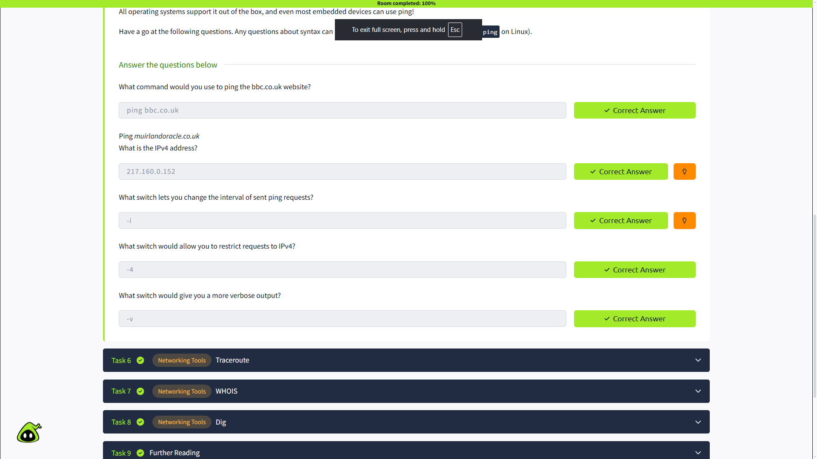

5. Networking Tools — Traceroute
In this section, I learned about Traceroute, a networking tool used to see the path that a request takes from my computer to a destination.
Unlike Ping, which mainly checks whether a connection is possible, Traceroute shows the intermediate steps, or hops, between the source and destination.
I also learned that the command is different depending on the operating system. On Linux, the basic syntax is:
traceroute <destination>
On Windows, the command is tracert.

Questions and Answers
Question:
“Use traceroute on tryhackme.com. Can you see the path your request has taken?”
My answer: Yes
Why:
I answered Yes because Traceroute displays the different intermediate network hops that the request passes through before reaching the destination.

Question:
“What switch would you use to specify an interface when using Traceroute?”
My answer: -i
Why:
I answered -i because this switch is used to specify the network interface that Traceroute should use.

Question:
“What switch would you use if you wanted to use TCP SYN requests when tracing the route?”
My answer: -T
Why:
I answered -T because this option tells Traceroute to use TCP SYN requests instead of its default method.

Question:
“Which layer of the TCP/IP model will Traceroute run on by default (Windows)?”
My answer: Internet Layer
Why:
I answered Internet Layer because the room explains that Windows tracert uses ICMP, and ICMP operates at the Network layer of the OSI model, which corresponds to the Internet layer in the TCP/IP model.

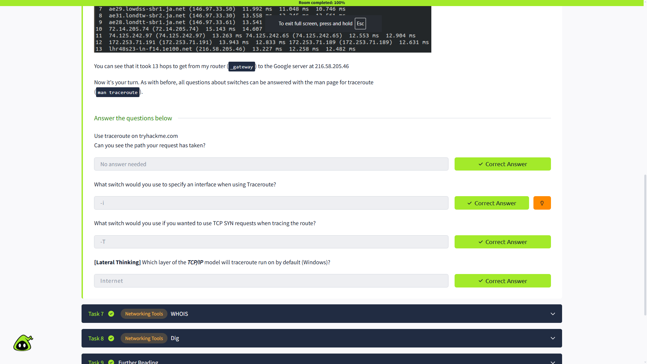

6. Networking Tools — WHOIS
In this section, I learned about WHOIS, a tool used to find information about a registered domain name.
I learned that domain names make it easier for people to access websites without having to remember their IP addresses. Domains are registered through domain registrars, and a WHOIS lookup can provide information about the registration of a domain.
I also learned the basic command:
whois <domain>
This can provide information such as the registrant details, registration dates, registrar, nameservers, and technical contact information. This type of information can also be useful during OSINT and cybersecurity investigations.

Questions and Answers
Question:
“Perform a WHOIS search on facebook.com.”
My answer: Completed
Why:
I performed a WHOIS lookup on the domain as instructed and used the information returned by the lookup to answer the following questions.

Question:
“What is the registrant postal code for facebook.com?”
My answer: [94025]
Why:
I found the postal code from the WHOIS information returned for the domain.

Question:
“When was the facebook.com domain first registered?”
My answer: [29/03/1997]
Why:
I checked the domain registration information provided by the WHOIS lookup and used the original registration date.

Question:
“Perform a WHOIS search on microsoft.com.”
My answer: Completed
Why:
I performed another WHOIS lookup, this time for microsoft.com, and used the returned registration information to answer the next questions.

Question:
“Which city is the registrant based in?”
My answer: [Redmond]
Why:
I found the city in the registrant information provided by the WHOIS lookup.

Question:
“What is the name of the golf course that is near the registrant address for microsoft.com?”
My answer: [Bellevue Golf Course]
Why:
This was an OSINT question. I used the registrant address from the WHOIS information and identified the nearby golf course.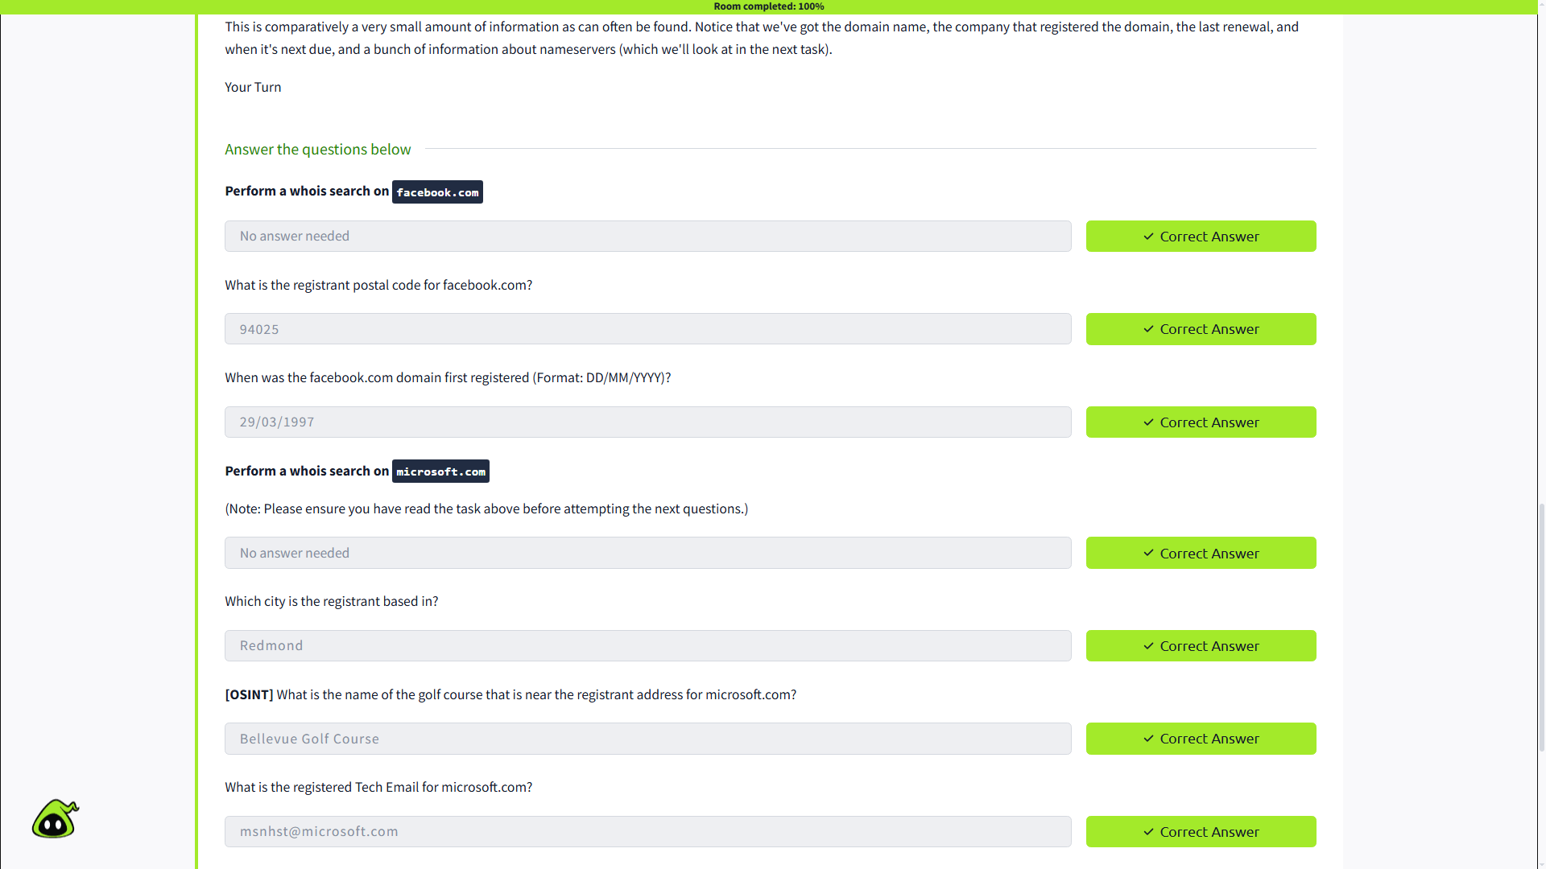

Question:
“What is the registered Tech Email for microsoft.com?”
My answer: [msnhst@microsoft.com]
Why:
I found the technical contact email in the WHOIS information for the Microsoft domain.

8. Networking Tools — Dig
In this section, I learned about DNS (Domain Name System) and how domain names are converted into IP addresses. DNS allows a computer to find the IP address of a website so it can connect to the correct server.
I learned that when a computer searches for a domain, it follows a process:
- First, it checks the local Hosts File.
- Then, it checks the local DNS cache.
- If the address is not found, it sends the request to a Recursive DNS Server.
- The recursive server may contact a Root Name Server.
- The request is then directed to a Top-Level Domain (TLD) Server, such as .com or .co.uk.
- Finally, the Authoritative Name Server provides the DNS record for the domain.
I also learned about the dig command, which can be used to manually query a DNS server.
Basic syntax:
dig <domain> @<dns-server-ip>
The dig output contains an ANSWER section, which shows the requested DNS information. I also learned about TTL (Time To Live), which tells the computer how long a DNS record can remain valid in its cache. TTL is measured in seconds.

Questions and Answers
1. What is DNS short for?
My answer was: Domain Name System
Why: DNS stands for Domain Name System and is used to translate domain names into IP addresses.

2. What is the first type of DNS server your computer would query when you search for a domain?
My answer was: Recursive DNS Server
Why: If the IP address is not found in the local Hosts File or DNS cache, the computer sends the request to a recursive DNS server.

3. What type of DNS server contains records specific to domain extensions (i.e. .com, .co.uk, etc.)? Use the long version of the name.
My answer was: Top-Level Domain (TLD) Server
Why: TLD servers handle specific domain extensions such as .com and .co.uk and direct the request to the appropriate authoritative name server.

4. Where is the very first place your computer would look to find the IP address of a domain?
My answer was: Hosts File
Why: The Hosts File is checked first for any manually created IP-to-domain mapping before the computer continues with the DNS process.

5. Google runs two public DNS servers. One of them can be queried with the IP 8.8.8.8. What is the IP address of the other one?
My answer was: 8.8.4.4
Why: Google provides 8.8.8.8 and 8.8.4.4 as its two public DNS server addresses.

6. If a DNS query has a TTL of 24 hours, what number would the dig query show?
My answer was: 86400
Why: TTL is measured in seconds.
24 hours × 60 minutes × 60 seconds = 86,400 seconds.
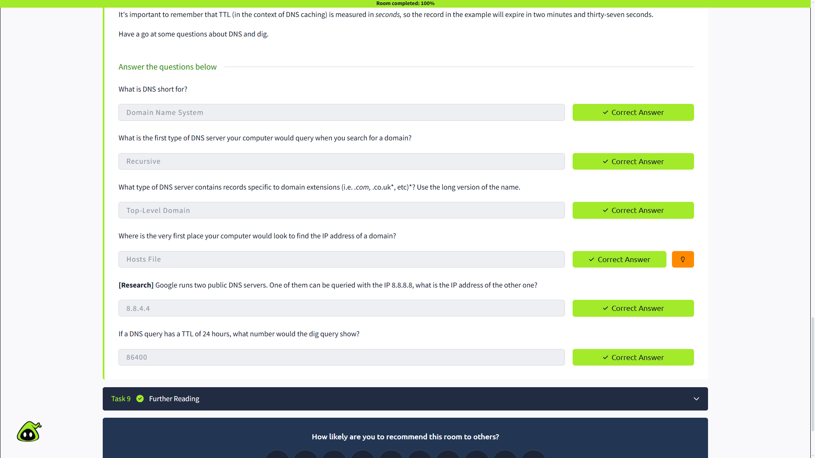

Key Takeaway
This room gave me a basic understanding of networking concepts, models, DNS, and common networking tools. I learned that networking is an important foundation for cybersecurity and should be studied continuously.

